Solve the equation or inequality. Write the answers to the inequalities in interval notation.

$x(1+3x)=(3x−1)(x−3)$

$3x^{2}+2x−8=0$

$(3x−4)^{2}−1=8$

$−3≤4x+2<\text{10}$

$(3x+5)^{−1}<0$

$x^{3}−5x^{2}−6x≥0$

Solve the problem.

1. The manager of a coffee shop has one type of coffee the sells for $5 per pound and another that sell for $14 per pound. The manager wishes to mix 30 pounds of the $14 coffee to get a mixture that will sell for $10 a pound. How many pounds of the $5 coffee should be used?
2. Two friends decide to meet in Houston for the Texans game next weekend. Deanna travels 231 miles in the same time that John travels 213 miles. Deanna's trip uses more interstate highways and she can average 6 mph more than John. What is Deanna's average speed?
3. Find the domain of $y=\frac{2x−3}{x^{2}−7}$.
4. Graph $y=−\frac{1}{2}(x−3)^{2}−1$



1. Graph $y=\frac{1}{2}\left|x−6\right|+1$



For Question #s 12-15, use the graph to the right.

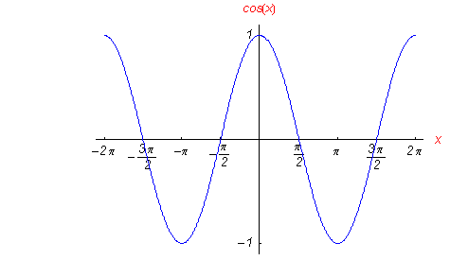

1. Evaluate $f(π)$.
2. What is the domain?

(Note that there are no arrows)

1. What is the range?
2. Where is the funciton increasing?

If $f(x)=4x−9$ and $g(x)=8x−4$

1. Evaluate $(f−g)(x)$.
2. Evaluate $(f⋅g)(2)\text{.}$
3. Evaluate $(f∘g)(1)$.
4. Find the vertical, horizontal, and oblique asymptotes (if any) of $f(x)=\frac{x−4}{x^{2}−5x−\text{14}}$.
5. Find x and y-intercepts of $f(x)=\frac{x^{2}−9}{x^{2}−5x−\text{14}}$.
6. Find the zeros of $f(x)=x^{3}−2x^{2}−x+2$. Use the Rational Root Theorem and synthetic division to help you.
7. Find the inverse of $f(x)={\left(x−3\right)}^{3}+4$.
8. Convert ${\text{log}}_{g}t=u$ to exponential form.

Solve for x.

${\left(\frac{1}{2}\right)}^{1+2x}=8$

$\text{log}(5x)=\text{log}2+\text{log}(x+3)$

The function $f(x)$ is graphed to the right.



1. On the same set of axes, graph $f(x−4)+3$.
2. On the same set of axes graph $f(x)$
3. How long will it take the sample of a radioactive substance that Homer Simpson carries home from work to decay to half of its original amount, if it decays according to the decay function where k=-.157? Round to the nearest hundredth of a year. (y=y0ekt)
4. A company manufactures three types of wooden chairs: the Kitui, the Goa, and the Santa Fe. To make a Kitui chair requires 1 hour of cutting time, 1.5 hours of assembly time, and 1 hour of finishing time. A Goa chair requires 1.5 hours of cutting time, 2.5 hours of assembly time and 2 hours of finishing time. A Santa Fe chair requires 1.5 hours of cutting time, 3 hours of assembly time, and 3 hours of finishing time. If 41 hours of cutting time, 70 hours of assembly time, and 58 hours of finishing time were used one week, how many of each type of chair were produced? **Only write an augmented matrix. DO NOT SOLVE!!**

Solve the system of equations using Gauss –Jordan Method (an augmented matrix).

$\left\{\begin{matrix}x−2y=2 \\ 3x−5y=9\end{matrix}\right.$

Solve the system using the inverse matrix method.

$\left\{\begin{matrix}x+3y=5 \\ 2x−3y=−8\end{matrix}\right.$ $\text{Note}:{\left[\begin{matrix}1 & 3 \\ 2 & −3\end{matrix}\right]}^{−1}=\left[\begin{matrix}1/3 & 1/3 \\ 2/9 & −1/9\end{matrix}\right]$